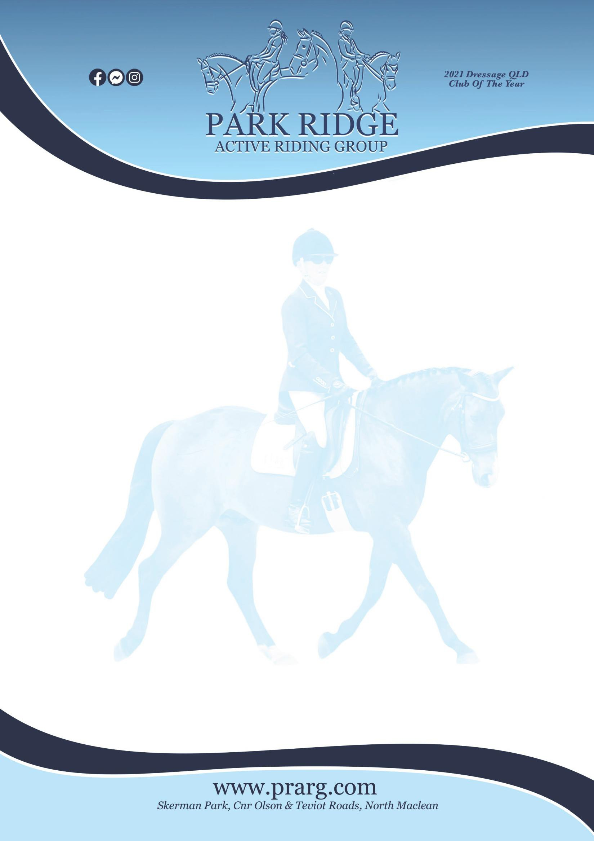

SADDLERY MARKET
Stall Holder Application & Waiver Form

Date of Event: | Saturday 31.10.2026
Location: | Skerman Pk, Cnr Olson and Teviot Rds, North Maclean Qld 4280
Stall Holder Full Name:
Address:
Email Address:
Or Mobile Number:
Fee Due: $15 either cash or eftpos per stall holder
In consideration for being permitted to participate in any way in horse sport activities, I, the undersigned, understand, acknowledge and accept that:
- I understand and acknowledge the dangers associated with the consumption of alcohol or any mind-altering drugs and agree not to drink alcohol or take drugs prohibited by law before or during any horse sports activities.
- I agree to follow the directions of any event organiser or official and that any misconduct or refusal by me to follow any direction of any organiser or official can result in the CANCELLATION of my participation in the activities and my immediate removal from the grounds.
- I have had sufficient opportunity to read this Stall Holder Acknowledgement and fully understand its terms and sign it freely and voluntarily.

Signature of Stall Holder: Dated:

